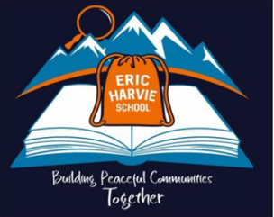
In recognition of National Indigenous Peoples Day,
and in alignment with the CBE Education Plan,
ERIC HARVIE SCHOOL
acknowledges and supports the Truth and Reconciliation Commission of Canada’s (TRC) Calls to Action, and makes the following commitments to action for the 2024-2025 school year:

- Engage the school community to create calendars that acknowledge and celebrate significant Indigenous cultural observances and events (e.g., Winter/Summer Solstice & Spring/Fall observances and events).

- Engage the school community to learn about the land where our school is located. Have students, staff, and families share their learning and make commitments to Truth & ReconciliACTION through the CBE Land Acknowledgement.

Date: June 21, 2024

